Austin Animal Shelter

SQL Report



Pic from <https://unsplash.com/s/photos/cat-and-dog>

**Prepared by Theresa Parker**

11/21/2022

**Table of Contents**

Executive Summary

Data Sources

Data Collection

Data Overview

Intakes Table

Rows and Columns:

Columns & Description:

Outcomes Table

Rows and Columns:

Columns & Description:

Limitations

Data Profile

Step 1: Cleaning the Data

Step 2: Manipulating the data

Step 3: Column Derivations/Aggregations

SQL Queries and Answers

1. What months are intakes the highest/lowest for ALL intakes?

2. What months are the busiest and slowest for adoptions?

3. What time of day are adoptions the highest and lowest?

4. Are there more cats or dogs at the shelter?

5. What is the most common age upon intake and outcomes?

6. What is the most common intake reason?

7. What is the most common type of outcome?

8. What are the top 3 dog and cat breeds?

9. Is there a color that is more common?

10. What are the top 10 names?

11. How many are euthanized each year?

12. What are the subtypes and percentages of those that are euthanized?

13. What are the subtypes and counts for animals that died?

14. How many are adopted each year?

15. What is the average length of time in the shelter from intake to adoption/euthanasia?

Digging Deeper

Summary of Findings

Animals

Shelter Volume

Intake Demographics

Outcome Demographics

Animal Demographics

Dogs

Cats

Recommendations

# **Executive Summary**

Exploratory Data Analysis conducted on our furry friends at Austin Animal Shelter. This project report covers years 2013 – 2021 and only includes cats and dogs. This analysis takes a look at cat/dog intakes and outcomes at the Austin Animal Shelter to see if there are any patterns or trends in order to help increase adoptions and decrease deaths.

# **Data Sources**

Dataset is from Kaggle titled [Animal Shelter Analytics](https://www.kaggle.com/datasets/jackdaoud/animal-shelter-analytics). There are two CSV files posted, intake and outcome information regarding the Austin Animal Center. Information is deemed to be from a reliable source as author of dataset indicated it is from a government website. Two datasets were used in this analysis.

1. Intakes
2. Outcomes

# **Data Collection**

I downloaded the two CSV files and created a database to import the tables into SQL so I could create a relational database.

# **Data Overview**

## Intakes Table

### Rows and Columns:

Original Dataset (Rows: 124,121 Columns: 12)

Final Dataset (Rows: 116,875 Columns: 13)

### Columns & Description:

Animal ID

Name

Date/Time

MonthYear

Found Location

Intake Type

Intake Condition

Animal Type:

Sex Upon Intake:

Age Upon Intake:

Breed:

Color:

## Outcomes Table

### Rows and Columns:

Original Dataset (Rows: 124,492 Columns: 12)

Final Dataset (Rows: 117,255 Columns: 14)

### Columns & Description:

Animal ID

Name:

Date/Time:

MonthYear

Date of Birth:

Outcome Type:

Outcome Subtype:

Animal Type:

Sex Upon Outcome:

Age Upon Outcome:

Breed:

Color:

# **Limitations**

* Data inaccuracy with intake/outcome numbers not matching.
* Some animals have negative ages
* Inconsistencies with names/breeds/etc.
* Upon reviewing the Breed and Color columns in both tables, there are several variables listed. This is something if I had access to the stakeholder we might be able to clean up, but for lack of knowledge, I will leave as is.

# **Data Profile**

## Step 1: Cleaning the Data

**1) Check Overview of the tables**.

-- OVERVIEW of Intakes

Select * from Intakes;

-- OVERVIEW of Outcomes

Select * from Outcomes;

**2) Change applicable column names to match on both spreadsheets for consistency purposes**.

* Example:
  + Intakes was named Animal_ID
  + Outcomes was named Animal ID (missing the underscore).

**3) Check for and remove duplicates**

-- DUPLICATES

-- Checking for Intake duplicates -- there are 23 intake duplicates

Select Animal_Id, Name, DateTime, COUNT(*)

From Intakes

Group By Animal_ID, Name, DateTime

Having Count (*) > 1

Order By Animal_ID;

-- Deleting Intake Duplicates - Deleted 23 values

WITH CTE AS

(

SELECT *,

ROW_NUMBER() OVER (PARTITION BY Animal_ID,Name,DateTime ORDER BY Animal_ID,Name,DateTime) AS RN

FROM Intakes

)

Delete FROM CTE WHERE RN<>1;

-- Checking for Outcomes duplicates -- there are 17 duplicates

Select Animal_Id, Name, DateTime, COUNT(*)

From Outcomes

Group By Animal_ID, Name, DateTime

Having Count (*) > 1

Order By Animal_ID;

-- Deleting Outcome Duplicates – Deleted 17 values

WITH CTE AS

(

SELECT *,ROW_NUMBER() OVER (PARTITION BY Animal_ID,Name,DateTime ORDER BY Animal_ID,Name,DateTime) AS RN

FROM Outcomes

)

DELETE FROM CTE WHERE RN<>1

**4) Checking for irrelevant information**

As this analysis is only for cats and dogs, I reviewed the animal type and needed to remove the other animals.

-- Checking Animal Type to ensure it is limited to cats and dogs.

-- There are Birds, Livestock, and Other that need to be removed as they are not part of this analysis.

Select Distinct Animal_Type

from Intakes

--Removing all animals from Intakes except cats or dog.

DELETE FROM Outcomes

WHERE Animal_Type like 'Bird' or Animal_Type like 'Livestock' or Animal_Type like 'Other'

DELETE FROM Intakes

WHERE Animal_Type like 'Bird' or Animal_Type like 'Livestock' or Animal_Type like 'Other'

**5) Data Consistency**

-- Need to change missing values in column Outcome_Type to Unknown

SELECT Distinct Outcome_Type from Outcomes

Select *

From outcomes

Where outcome_type = ''

Update outcomes

Set Outcome_Type = 'Unknown'

Where outcome_Type = ''

--Checking null values in Sex_upon_intake - There is 1 value NULL that needs to be changed to Unknown in Intakes table.

SELECT Distinct sex_upon_intake from intakes;

SELECT *

FROM intakes

WHERE sex_upon_intake = 'Unknown';

Update dbo.Intakes

SET Sex_upon_Intake = REPLACE(Sex_upon_Intake, 'NULL', 'Unknown')

WHERE Sex_upon_Intake = 'NULL'

--Checking null values in Sex_upon_intake - There is 1 value NULL that needs to be changed to Unknown in Outcomes table.

SELECT Distinct sex_upon_outcome from Outcomes

SELECT sex_upon_outcome from Outcomes

Where sex_upon_outcome = 'NULL'

Update dbo.Outcomes

SET Sex_Upon_Outcome = 'Unknown'

Where Sex_Upon_Outcome = 'NULL'

-- Checking the age values. There are -1 year, -2, and -3 years for a total of 7 values that need to be removed as you cannot have a negative age.

SELECT Distinct age_upon_intake from intakes

Order by age_upon_intake

SELECT Animal_ID, Name, DateTime, age_upon_intake

from intakes

WHERE age_upon_intake like '-1 years' or age_upon_intake like '-2 years' or Age_upon_Intake like '-3 years'

Order by age_upon_intake

-- Deleting age upon Intake with negative years

DELETE from dbo.intakes

WHERE age_upon_intake like '-1 years' or age_upon_intake like '-2 years' or Age_upon_Intake like '-3 years'

-- Deleting age upon Outcome with negative years

DELETE from dbo.Outcomes

WHERE [Age upon Outcome] like '-1 years' or [Age upon Outcome] like '-2 years' or [Age upon Outcome] like '-3 years'

--Outcomes table has datetime listed as varchar, need to change to datetime

ALTER TABLE Outcomes

ALTER COLUMN DateTime datetime;

## Step 2: Manipulating the data

**1) Removing MonthYear Column from both Intakes and Outcomes as it contains the same information that is in Date/Time column.**

--Removing column MonthYear from Intake

Alter table dbo.intakes

Drop column MonthYear

--Removing column monthYear from Outcomes

Alter table dbo.outcomes

Drop column MonthYear

**2) Updating the structural errors in the Name column**

--Intake Name Column needs adjusting those with an asterick. 27,803 Rows Updated

SELECT [Name],

REPLACE([Name], '*', '') AS [Clean Name]

FROM dbo.intakes

Where Name Like '%*%'

Order By name desc

UPDATE dbo.intakes

SET Name = REPLACE(Name, '*', '')

WHERE Name Like '%*%'

--Outcome Name Column needs adjusting those with an asterick.

SELECT [Name], -- 28,080 rows to be updated

REPLACE([Name], '*', '') AS [Clean Name]

FROM dbo.Outcomes

Where Name Like '%*%'

Order By name desc

Update dbo.outcomes

SET Name = REPLACE([Name], '*', '')

Where Name Like '%*%'

-- Intake Viewing and Updating Null values to Unknown in Name 32,788 values

Select Name

From Intakes

Where Name is NULL

UPDATE intakes

Set Name = 'Unknown'

Where Name is NULL

-- Outcome Viewing and Updating Empty values to Unknown 32,788 values

Update dbo.outcomes

SET Name = 'Unknown'

WHERE Name = ''

-- Updating Names that are only numbers. - 179 rows

SELECT Name

FROM OUTCOMES

Where Name not like '%[A-Za-z]%'

Update Outcomes

Set Name ='Unknown'

Where Name not like '%[A-Za-z]%'

--Removing Grams from Name

SELECT [Name],

REPLACE([Name], 'Grams', '') AS [Clean Name]

FROM dbo.intakes

Where Name Like '%Grams%

Order By name desc

## Step 3: Column Derivations/Aggregations

**1) Adding Columns and Creating Variable Derivations**

--Updating Intake and Outcome table to add Date_Converted and Time Converted columns

Alter Table intakes

Add Date_Converted date,

Time_Converted time;

Alter Table Outcomes

Add Date_Converted date,

Time_Converted time;

--Converting Intake Date/Time and extracting the Date only

Select datetime,

convert(varchar,[datetime], 101) Converted_Date

from Intakes

Update intakes

Set Date_Converted = FORMAT([datetime], 'MM-dd-yyyy')

Where Date_Converted is NOT NULL

-- Extracting time only in am/pm - 116875 rows effected

Select * from Intakes

SELECT DateTime,

FORMAT([datetime], 'hh:mm tt') AS Converted_Date

from Intakes

Update intakes

Set Time_Converted = FORMAT([datetime], 'hh:mm tt')

Where Time_Converted is NULL

--Converting Date/Time and extracting the Date only for outcomes table-- 117255 rows effected

Select Datetime,

Convert (varchar,[datetime], 101) Test

From Outcomes

Update Outcomes

Set Date_Converted = Convert (varchar,[datetime], 101)

--Converting Outcome Date/Time and extracting the Time only. tt refers to am/pm

Select * from Outcomes

SELECT DateTime,

FORMAT([datetime], 'hh:mm tt') AS Converted_Date

from Outcomes

Update Outcomes

Set Time_Converted = FORMAT([datetime], 'hh:mm tt')

Where Time_Converted is NULL

**2) Adding New column for Year only.**

--Adding a new column to table for Year

ALTER TABLE OUTCOMES

ADD YEAR SMALLINT;

--Adding Year values to Year column

UPDATE OUTCOMES

SET YEAR = DATEPART(YEAR, DATE_CONVERTED)

WHERE YEAR is NULL

DATA PROFILE FINAL NOTES:

1. Those names including gram in them will not make a difference when filtering for top 100 Names, therefore, going to leave names as is.

2. Leaving Address alone since it's not delimited and messy. Due to time constraints leaving as is and will not use Address in the evaluation.

# **SQL Queries and Answers**

## What months are intakes the highest/lowest for ALL intakes?

--Busiest intake month by count

With CTE AS

(

Select *, DATEPART(month, Date_Converted) AS Intake_Month

From Intakes

)

Select Top 3

Intake_Month, Count(*) AS Top_Month_Count

from CTE

Group by Intake_Month

Order by Top_Month_Count desc;

--Slowest month by count

With CTE AS

(

Select *, DATEPART(month, Date_Converted) AS Intake_Month

From Intakes

)

Select Top 3

Intake_Month, Count(*) AS Lowest_Month_Count

from CTE

Group by Intake_Month

Order by Lowest_Month_Count asc;

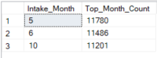

--Busiest intake month by count

* May, June, October

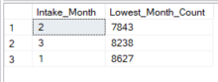

--Least busy intake month by count

* February, March, January

## What months are the busiest and slowest for adoptions?

--Busiest Adoption Month

With CTE AS

(

Select *, DATEPART(month, Date_Converted) AS Intake_Month

From Outcomes

)

Select Top 3

Intake_Month, Count(*) AS Month_Count

from CTE

WHERE Outcome_Type like 'Adoption'

Group By Intake_Month

Order by Month_Count desc

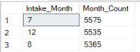

--Least Busy Adoption Months

With CTE AS

(

Select *, DATEPART(month, Date_Converted) AS Intake_Month

From Outcomes

)

Select Top 3

Intake_Month, Count(*) AS Month_Count

from CTE

WHERE Outcome_Type like 'Adoption'

Group By Intake_Month

Order by Month_Count asc

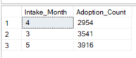

--Busiest Adoption Months by Count

* July, December, August

--Slowest Adoption Months by Count

* April, March, May

## What time of day are adoptions the highest and lowest?

-- What time of day are adoptions the highest?

WITH CTE AS

(

SELECT *, DATEPART(Hour, Time_Converted) AS Adoption_Hour

From Outcomes

)

SELECT Top 3

Adoption_Hour, COUNT(*) AS Adoption_Hour_Count

From CTE

WHERE Outcome_Type like 'Adoption'

GROUP BY Adoption_Hour

ORDER BY Adoption_Hour_Count desc

--Time of day adoptions are the lowest?

WITH CTE AS

(

SELECT *, DATEPART(Hour, Time_Converted) AS Adoption_Hour

From Outcomes

)

SELECT Top 3

Adoption_Hour, COUNT(*) AS Adoption_Hour_Count

From CTE

WHERE Outcome_Type like 'Adoption'

GROUP BY Adoption_Hour

ORDER BY Adoption_Hour_Count asc

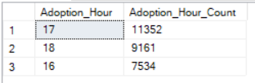

**Busiest Hour:**

-- **5pm** = 11352

-- **6pm** = 9161

--  **4pm** = 7534

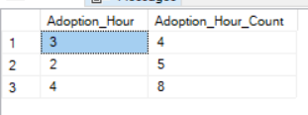

**Slowest Lowest:**

-- **3am** = 4

-- **2am** = 5

-- **4am** = 8

## Are there more cats or dogs at the shelter?

-- Total Count

Select COUNT(Animal_Type)

from Intakes

-- Cat and Dog Counts and Percentages

Select Animal_Type,

Count(Animal_Type) as Animal_Count,

ROUND(count(*) * 100.0 / sum(count(*)) over(),0) AS Percentage_Outcome

from Intakes

Group by Animal_Type

Order by Percentage_Outcome desc

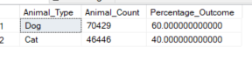

## What is the most common age upon intake and outcomes?

--Counts by Age Upon Intake

Select Distinct Top 3 Age_Upon_Intake,

Count(Age_Upon_Intake) over (partition by Age_Upon_Intake) as Age_Count

from Intakes

Order by Age_Count desc

--Counts by Age Upon Outcomes

Select Distinct Age_Upon_Outcome,

Count(Age_Upon_Outcome) over (partition by Age_Upon_Outcome) as Age_Count

from Outcomes

Order by Age_Count desc

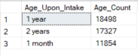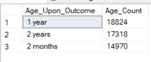

**Intake:**

-- 18,498 at 1 year old

-- 17,327 at 2 years old

-- 11,854 at 1 month old

**Outcomes:**

-- 18824 at 1 year old

-- 17318 at 2 years old

-- 14970 at 2 months old

## What is the most common intake reason?

-- Viewing total number of intake types - 116,875

Select COUNT(Intake_Type)

from Intakes

-- Viewing Count of Intake_Type

Select Distinct Intake_Type,

Count(Intake_Type) over (partition by Intake_type) as Intake_Count

from Intakes

Order by Intake_Count desc

--Viewing Percentage of Intake_Count

Select Intake_Type,

ROUND(count(*) * 100.0 / sum(count(*)) over(),1) AS Percentage_Outcome

from Intakes

Group by Intake_Type

Order by Percentage_Outcome desc

--Viewing Subtype of Owner Surrender

With CTE AS

(

Select *

from Intakes

Where Intake_Type = 'Owner Surrender'

)

Select Intake_Condition,

ROUND(count(*) * 100.0 / sum(count(*)) over(),1) AS Condition_Outcome

from Intakes

Group by Intake_Condition

Order by Condition_Outcome desc

Strays = 73% of Intake Type

Owner Surrenders = 21%

* + - * Normal conditions  = 88.3%
      * Injured = 4.8%
      * Sick = 3.1%
      * Nursing = 2.9%
      * Aged = .4%
      * Other = .2%
      * Pregnant = .1%
      * Medical  = .1%
      * Feral  = .1%
      * Behavior = .000%)

Public Assist = 6%

Abandoned = > 1%

Euthanasia Request = > 1%

## What is the most common type of outcome?

--Outcome type by count

Select Distinct Outcome_Type,

Count(Outcome_Type) over (partition by Outcome_type) as Outcome_Count

from Outcomes

Order by Outcome_Count desc

--Outcome type by Percentage

Select Distinct Outcome_Type,

Count(Outcome_Type) over (partition by Outcome_type) as Outcome_Count

from Outcomes

Order by Outcome_Count desc

--Subtypes of Euthanasia

With CTE AS

(

Select *

from Outcomes

Where Outcome_Type = 'Euthanasia'

)

Select Outcome_Subtype,

ROUND(count(*) * 100.0 / sum(count(*)) over(),1) AS Subtype_Outcome

from CTE

Group by Outcome_Subtype

Order by Subtype_Outcome desc

--Adoption = 54609 / 46.6%

--Transfer = 35649 / 30.4%

--Return to Owner = 21428 / 18.3%

--Euthanasia = 3738 / 3.2%

(Reasons for Euthanasia)

* + - Suffering 67.1%
    - Aggressive 14.4%
    - Rabies Risk 4.8%
    - Beahvior 4.3%
    - At Vet 4.2%
    - Medical 3.8%
    - Court/Investigation .8%
    - Blank .7%

--Died = 944 / .8%

--Rto-Adopt = 694 / .6%

--Disposal = 112 / .1%

--Missing = 64 / .1%

--Unknown = 15 / 0%

--Relocate = 2 / 0%

## What are the top 3 dog and cat breeds?

--Top DOG breed in Intakes:

Select Top 3 Breed,

ROUND(count(*) * 100.0 / sum(count(*)) over(),1) AS Breed_Percentage

from intakes

Where Animal_Type = 'Dog'

Group by Breed

Order by Breed_Percentage desc

--Top Dog Adopted Breeds:

With CTE AS

(

Select *

from Outcomes

Where Outcome_Type = 'Adoption' and Animal_Type = 'Dog'

)

Select Breed,

ROUND(count(*) * 100.0 / sum(count(*)) over(),1) AS Breed_Adopted

from CTE

group by Breed

Order by Breed_Adopted desc

--Top Dog Euthanized Breeds:

With CTE AS

(

Select *

from Outcomes

Where Outcome_Type = 'Euthanasia' and Animal_Type = 'Dog'

)

Select Breed,

ROUND(count(*) * 100.0 / sum(count(*)) over(),1) AS Breed_Euthanized

from CTE

Group by Breed

Order by Breed_Euthanized desc

--Top CAT breed in Intakes:

Select Top 10 Breed,

ROUND(count(*) * 100.0 / sum(count(*)) over(),1) AS Breed_Percentage

from intakes

Where Animal_Type = 'Cat'

Group by Breed

Order by Breed_Percentage desc

--Top Cat Adopted Breeds:

With CTE AS

(

Select *

from Outcomes

Where Outcome_Type = 'Adoption' and Animal_Type = 'Cat'

)

Select Breed,

ROUND(count(*) * 100.0 / sum(count(*)) over(),1) AS Breed_Adopted

from CTE

Group by Breed

Order by Breed_Adopted desc

--Top Cat Euthanized Breeds:

With CTE AS

(

Select *

from Outcomes

Where Outcome_Type = 'Euthanasia' and Animal_Type = 'CAT'

)

Select Breed,

ROUND(count(*) * 100.0 / sum(count(*)) over(),1) AS Breed_Euthanized

from CTE

Group by Breed

Order by Breed_Euthanized desc

**Dogs:**

Top Intake Dog is: Pitbull Mix, Labrador Retriever Mix, Chihuahua Shorthair mix

Top Adopted Dog is: Labrador Retriever Mix, Pitbull Mix, Chihuahua Mix

Top Euthanized Dog: Pitbull, Chihuahua Mix, Labrador Retriever Mix

**Cats:**

Top Intake Cat is: Domestic Shorthair Mix, Domestic Shorthair, Domestic Medium Hair Mix

Top Adopted Cat is: Domestic Shorthair Mix, Domestic Shorthair, Domestic Medium Hair Mix

Top Euthanized Cat: Domestic Shorthair Mix, Domestic Shorthair, Domestic Medium Hair Mix

## Is there a color that is more common?

--Top 3 color intakes in Dog

Select Top 3 Color

From Intakes

Where Animal_Type = 'Dog'

--Top 3 color of adopted dogs

Select Top 3 Color, Count(*) AS color_count

From Outcomes

Where Animal_Type = 'Dog' and Outcome_type = 'Adoption'

Group By color

Order by color_count desc

--Top 3 color of dogs that are Euthanized

Select Color, Count(*) AS color_count

From Outcomes

Where Animal_Type = 'Dog' and Outcome_type = 'Euthanasia'

Group By color

Order by color_count desc

--Top 3 color intakes in Cats

Select Top 3 Color

From Intakes

Where Animal_Type = 'Cat'

--Top 3 color of adopted Cats

Select Top 3 Color, Count(*) AS color_count

From Outcomes

Where Animal_Type = 'Cat' and Outcome_type = 'Adoption'

Group By color

Order by color_count desc

--Top 3 color of Cats that are Euthanized

Select Color, Count(*) AS color_count

From Outcomes

Where Animal_Type = 'Cat' and Outcome_type = 'Euthanasia'

Group By color

Order by color_count desc

**Dogs:**

* Intakes

Tricolor

White/Liver

Sable/White

* Adopted

Black/White = 4236

Brown/White = 1880

Tan/White = 1869

* Euthanized

Black/White - 166

Brown/White - 113

Tan/White 107

**Cats:**

* Intakes

Calico

Cream Tabby

Black/White

* Adopted

Brown Tabby

Black

Black/White

* Euthanized

Brown Tabby

Black

Black/White

## What are the top 10 names?

--Top 10 Cat names

Select Top 10 Name, Count(*) as Cat_Count

From Outcomes

Where Animal_Type = 'Cat' and Name <> 'Unknown'

Group By Name

Order by Cat_Count desc

--Top 10 Dog names

Select Top 10 Name, Count(*) as Dog_Count

From Outcomes

Where Animal_Type = 'Dog' and Name <> 'Unknown'

Group By Name

Order by Dog_Count desc

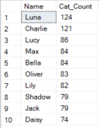 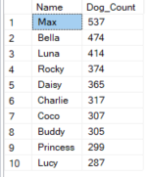

**--Top 10 Cat Names**

Luna = 124

Charlie = 121

Lucy = 86

Max = 84

Bella = 84

Oliver = 83

Lily = 82

Shadow = 79

Jack = 79

Daisy = 74

**--Top 10 Dog Names**

Max = 537

Bella = 474

Luna = 414

Rocky = 374

Daisy = 365

Charlie = 317

Coco = 307

Buddy = 305

Princess = 299

Lucy = 287

## How many are euthanized each year?

--Total

Select datepart(year, Date_Converted) as Year, count(*) as Year_Count

from Outcomes

Where Outcome_Type = 'Euthanasia'

Group by datepart(Year, Date_Converted)

Order by Year_Count desc

--Dogs

Select datepart(year, Date_Converted) as Year, count(*) as Year_Count

from Outcomes

Where Outcome_Type = 'Euthanasia' and Animal_Type = 'Dog'

Group by datepart(Year, Date_Converted)

Order by Year_Count desc

--Cats

Select datepart(year, Date_Converted) as Year, count(*) as Year_Count

from Outcomes

Where Outcome_Type = 'Euthanasia' and Animal_Type = 'Cat'

Group by datepart(Year, Date_Converted)

Order by Year

--Pivot Table of Euthanizing Counts by Year

SELECT * FROM

(

Select

Year,

Animal_Type,

COUNT(*) As Adoption_Count

FROM Outcomes

WHERE Outcome_Type ='Euthanasia'

Group by Animal_Type, Year

) t

PIVOT(

SUM (Adoption_Count)

FOR [Year]

IN (

[2013],

[2014],

[2015],

[2016],

[2017],

[2018],

[2019],

[2020],

[2021])

) AS pivot_table;



**Total Chronological    Total By Count**

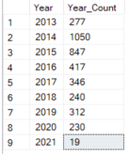 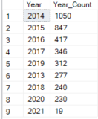

**Dogs Chronological   Dogs By Count**

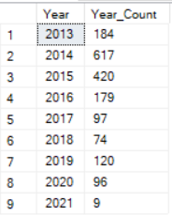 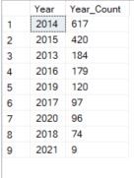

**Cats Chronological    Cats By Count**

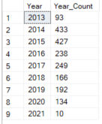 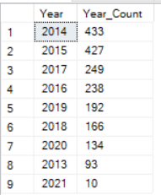

## What are the subtypes and percentages of those that are euthanized?

With CTE AS

(

Select *

from Outcomes

Where Outcome_Type = 'Euthanasia'

)

Select Outcome_Subtype,

ROUND(count(*) * 100.0 / sum(count(*)) over(),0) AS [Percentage_Euthanized]

from CTE

Group by Outcome_Subtype

Order by Percentage_Euthanized desc

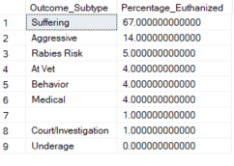

## What are the subtypes and counts for animals that died?

***Overview and thoughts on analysis:

1. Roughly half the number of pets die in foster care opposed to in the Kennel
2. There is a blank category where every year deaths that are not Euthanasia related are not categorized.
3. 51% of the cats have died in the Kennel compared to 61% of dogs.
4. 11.3% of the dogs die at the Vet compared to 7.6%

--Count of the reason where outcome type is Died

Select distinct outcome_subtype, COUNT(*) as count_subtype

from outcomes

Where outcome_type = 'died'

Group by Outcome_Subtype

Order by count_subtype desc

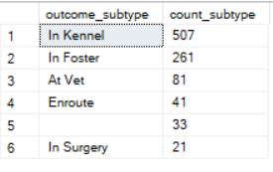

--Count of those who died in Care by Year and the Reason why

Select datepart(year, date_converted) as year,

COUNT(outcome_subtype) AS sub_count, Outcome_Subtype

from outcomes

Where Outcome_Type = 'Died'

Group by outcome_subtype, datepart(year, date_converted)

Order by datepart(year, date_converted), outcome_subtype

Year Count Reasons for “Died”

2013 1

2013 8 In Foster

2013 13 In Kennel

2013 1 In Surgery

2014 16

2014 4 At Vet

2014 6 Enroute

2014 36 In Foster

2014 38 In Kennel

2014 2 In Surgery

2015 6

2015 5 At Vet

2015 5 Enroute

2015 31 In Foster

2015 97 In Kennel

2015 2 In Surgery

2016 1

2016 10 At Vet

2016 2 Enroute

2016 40 In Foster

2016 86 In Kennel

2016 5 In Surgery

2017 1

2017 12 At Vet

2017 5 Enroute

2017 41 In Foster

2017 58 In Kennel

2017 5 In Surgery

2018 18 At Vet

2018 9 Enroute

2018 30 In Foster

2018 74 In Kennel

2018 2 In Surgery

2019 7

2019 26 At Vet

2019 7 Enroute

2019 46 In Foster

2019 97 In Kennel

2019 4 In Surgery

2020 1

2020 6 At Vet

2020 7 Enroute

2020 28 In Foster

2020 42 In Kennel

2021 1 In Foster

2021 2 In Kennel

--Count of the reason where outcome type is Died for dogs

Select distinct outcome_subtype, COUNT(*) as count_subtype, ROUND(count(*) * 100.0 / sum(count(*)) over(),0) AS dog_percent_subtype

from outcomes

Where outcome_type = 'died' and animal_type = 'Dog'

Group by Outcome_Subtype

Order by count_subtype desc

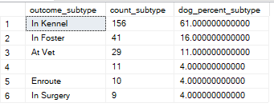

--Count of the reason where outcome type is Died for cats

Select distinct outcome_subtype, COUNT(*) as count_subtype, ROUND(count(*) * 100.0 / sum(count(*)) over(),0) AS cat_percent_subtype

from outcomes

Where outcome_type = 'died' and animal_type = 'Cat'

Group by Outcome_Subtype

Order by count_subtype desc

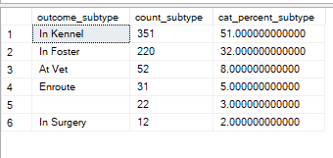

## How many are adopted each year?



This can be broken down many different ways. Here is each way and the respective results.

-- Count and total Percentage of Cat Adoptions by Subtype

Select outcome_subtype,

COUNT(*) as cat_adoptions,

ROUND(count(*) * 100.0 / sum(count(*)) over(),0) AS cat_percent_subtype

from outcomes

Where outcome_type = 'Adoption' and animal_type = 'Cat'

Group by Outcome_Subtype

Order by cat_adoptions desc

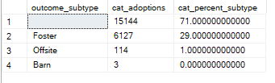

-- Count and total Percentage of Dog Adoptions by Subtype

Select distinct outcome_subtype,

COUNT(*) as dog_adoptions,

ROUND(count(*) * 100.0 / sum(count(*)) over(),0) AS dog_percent_subtype

from outcomes

Where outcome_type = 'Adoption' and animal_type = 'Dog'

Group by outcome_subtype

Order by dog_adoptions desc

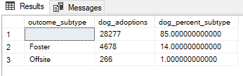

-- Cat adoptions by year without Subtype

Select Year, COUNT (*) AS Cat_Adoptions

from outcomes

Where Outcome_Type = 'Adoption' and animal_type = 'Cat'

Group by Outcome_type, Year

Order by Year, outcome_type

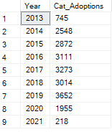

--Dog adoptions by year without Subtype

Select datepart(year, date_converted) as year,COUNT (*) AS dog_adoptions

from outcomes

Where Outcome_Type = 'Adoption' and animal_type = 'Dog'

Group by Outcome_type, datepart(year, date_converted)

Order by datepart(year, date_converted)

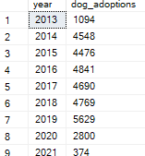

-- Dog and Cat Adoption adopted by year

Select Animal_Type,

COUNT(*) as Animal_Count,

datepart(year, date_converted) as Year

from Outcomes

Where Outcome_Type = 'Adoption'

Group by Animal_Type, datepart(year, date_converted)

Order by datepart(year, date_converted) asc

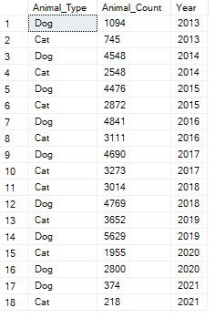

---Pivot Table to show cat and dog adoptions by year

SELECT * FROM

(

Select

Year,

Animal_Type,

COUNT(*) As Adoption_Count

FROM Outcomes

WHERE Outcome_Type ='Adoption'

Group by Animal_Type, Year

) t

PIVOT(

SUM (Adoption_Count)

FOR [Year]

IN (

[2013],

[2014],

[2015],

[2016],

[2017],

[2018],

[2019],

[2020],

[2021])

) AS pivot_table;



## What is the average length of time in the shelter from intake to adoption/euthanasia?

** We were given an animal_ID for the dataset, but there was not a way to differentiate the animals if they came to the shelter multiple times. The challenge was trying to align the correct intake time with outcome time when calculating the DATEDIFF. There bad data because the number of intakes did not always match the number of outcomes for a pet. Or there were times where an outcome would happen prior to an intake.

For these reasons, I will not provide an answer, but show you how I would query the information if the data was complete and there was an exact match for each intake/outcome.

--Joining tables to see the difference between intake and outcome time.

Select a.animal_id,

a.datetime [intake_time],

b.animal_id,

b.datetime [outcome_time],

DATEDIFF(month,a.DateTime, b.DateTime) AS Month_Diff

from intakes a

inner join outcomes b

ON a.animal_id = b.animal_id

Order by Month_Diff desc

An example of how the information does not line up:

* An animal cannot be in the shelter for a negative amount of time
* I am not certain that an Animal Shelter would hold on to an animal for 6 years if it has not been adopted when they have Euthanasia as an option.

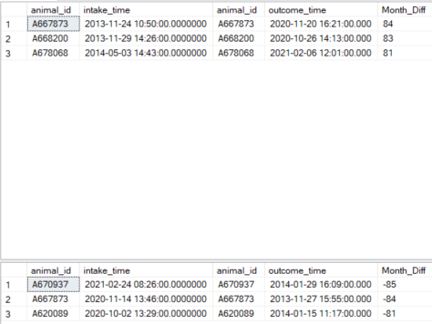

**Here is how I would query the Average time from intake to adoption:**

The average length of time between intake and adoption is 26 days.

33 days for cats

22 days for dogs

--Average days to adoption for both cats and dogs.

Select AVG(DATEDIFF(day,a.DateTime, b.DateTime)) AS Average_Adoption_Days

from intakes a

inner join outcomes b

on a.animal_id = b.animal_id

Where outcome_type = 'Adoption'



--Average days to adoption for cats.

Select AVG(DATEDIFF(day,a.DateTime, b.DateTime)) AS Average_Cat_Days

from intakes a

inner join outcomes b

on a.animal_id = b.animal_id

Where outcome_type = 'Adoption' and b.Animal_Type = 'Cat'



--Average days to adoption for Dogs.

Select AVG(DATEDIFF(day,a.DateTime, b.DateTime)) AS Average_Dog_Days

from intakes a

inner join outcomes b

on a.animal_id = b.animal_id

Where outcome_type = 'Adoption' and b.Animal_Type = 'Dog'



**Here is how I would query the Average time from intake to Euthanasia:**

The average length of time between intake and adoption is 26 days.

* + 33 days for cats
  + 22 days for dogs

Select AVG(DATEDIFF(day,a.DateTime, b.DateTime)) AS Avg_Total_Days

from intakes a

inner join outcomes b

on a.animal_id = b.animal_id

Where outcome_type = 'Euthanasia'



Select AVG(DATEDIFF(day,a.DateTime, b.DateTime)) AS Cat_Days

from intakes a

inner join outcomes b

on a.animal_id = b.animal_id

Where outcome_type = 'Euthanasia' and b.Animal_Type = 'Cat'



Select AVG(DATEDIFF(day,a.DateTime, b.DateTime)) AS Dog_Days

from intakes a

inner join outcomes b

on a.animal_id = b.animal_id

Where outcome_type = 'Euthanasia' and b.Animal_Type = 'Dog'



# **Digging Deeper**

I want to see the amount of time between intake and Outcome for animals who are Euthanized that were brought in under Normal Conditions. I found some results that require further digging.

Select i.Animal_ID,

o.Animal_ID,

i.DateTime,

o.DateTime,

case when i.DateTime > o.DateTime THEN

DATEDIFF(hour,o.DateTime,i.datetime)

ELSE

DATEDIFF(hour,i.DateTime,o.datetime)

END AS [Datediff_hours],

i.Intake_Type,

i.intake_condition,

o.Outcome_Type,

o.Outcome_Subtype

from Intakes i

left join Outcomes o on o.Animal_ID = i.Animal_ID

Where o.Animal_ID IS NOT NULL

and o.Outcome_type = 'Euthanasia'

and i.intake_condition = 'Normal'

Order by Datediff_hours

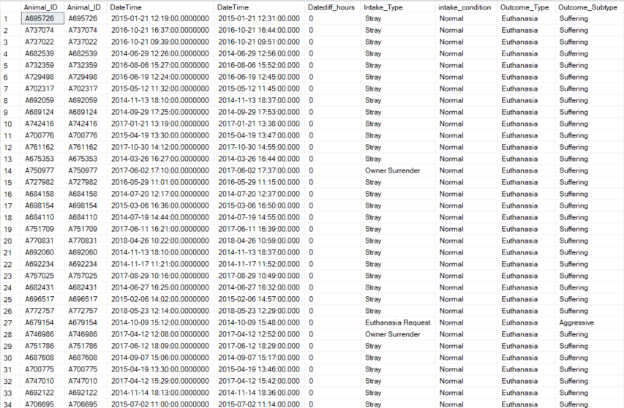

To check the results of my query, I looked at the first animal on the list. It lists a 5 year old cat brought into the shelter as a Stray under Normal conditions, but Euthanized indicating they were suffering. Why is that the case?

select * from intakes where animal_id = 'A695726'

select * from outcomes where animal_id = 'A695726'



Looking at the second animal_id from the query above, it is a 4 week old stray puppy in normal condition but was Euthanized 7 minutes later as the outcome subtype indicated Suffering.

How can an animal brought in under normal conditions suffer so much that within 7 minutes needs be Euthanized????

select * from intakes where animal_id = 'A737074'

select * from outcomes where animal_id = 'A737074'



**Dig Deeper Thoughts:** There are several animals brought into the shelter as a Stray Under Normal Conditions and were Euthanized less than 1 hour later indicating they were Suffering.

Here are some follow up questions that I have:

* What is the definition of “Suffering” to Austin Animal Shelter?
* What is the definition of an Intake Type Normal Condition?
* Are all employees trained and using the definitions of the intake conditions and outcome subtypes correctly?
  + If these fields are not being consistently and accurately entered then the data can be significantly skewed in an improper direction resulting in inaccurate reasons why an animal was Euthanized.
* Was the shelter at max capacity if the animal was under normal conditions and there was no where else transfer or house the animal?
* How can an animal be deemed as Suffering, if it is within less than an hour?

# **Summary of Findings**

## Animals

* There are more dogs than cats at the shelter.

## Shelter Volume

**Busiest Intake times:**

* Months – May, June, October
* Time of Day: Late afternoon / Evenings 4-6 with 5 being peak

**Slowest Intake Times**

* Months – February, March, January
* Time of Day: During working hours the early mornings are slowest.

**Busiest Adoption times:**

* Months – July, December, August
* Time of Day: Late afternoon / Evenings 4-6 with 5 being peak

**Slowest Adoption Times**

* Months – April, March, May
* Time of Day: During working hours the early mornings are slowest.

## Intake Demographics

* Age Upon Intake: Most common years at Intake: 1 year, 2 year, 1 month
* Top 2 Intake Reason:
  + Strays = 73%
  + Owner Surrender = 21%
    - Out of the Owner Surrender 88.3% have an intake listing Normal Condition

## Outcome Demographics

* Age Upon Outcome: Most common years at Outcomes: 1 year, 2 years, 2 months.
* Top 2 Outcomes
  + Adoption 46.6%
  + Transfers 30.4%
* Euthanasia Count by Year



* Adoption Count by Year:



* Animals that Died without Euthanasia



* Animals that Died without Euthanasia by Year

Year Count Reasons for “Died”

2013 1

2013 8 In Foster

2013 13 In Kennel

2013 1 In Surgery

2014 16 Blank

2014 4 At Vet

2014 6 Enroute

2014 36 In Foster

2014 38 In Kennel

2014 2 In Surgery

2015 6 Blank

2015 5 At Vet

2015 5 Enroute

2015 31 In Foster

2015 97 In Kennel

2015 2 In Surgery

2016 1 Blank

2016 10 At Vet

2016 2 Enroute

2016 40 In Foster

2016 86 In Kennel

2016 5 In Surgery

2017 1 Blank

2017 12 At Vet

2017 5 Enroute

2017 41 In Foster

2017 58 In Kennel

2017 5 In Surgery

2018 18 At Vet

2018 9 Enroute

2018 30 In Foster

2018 74 In Kennel

2018 2 In Surgery

2019 7 Blank

2019 26 At Vet

2019 7 Enroute

2019 46 In Foster

2019 97 In Kennel

2019 4 In Surgery

2020 1 Blank

2020 6 At Vet

2020 7 Enroute

2020 28 In Foster

2020 42 In Kennel

2021 1 In Foster

2021 2 In Kennel

## Animal Demographics

### Dogs

* **Top Dogs Breeds:**

Top Intake Dog Breed: Pitbull Mix, Labrador Retriever Mix, Chihuahua Shorthair mix

Top Adopted Breed: Labrador Retriever Mix, Pitbull Mix, Chihuahua Mix

Top Euthanized Breed: Pitbull, Chihuahua Mix, Labrador Retriever Mix

* **Top Dog Color:**

* Intakes

Tricolor

White/Liver

Sable/White

* Adopted

Black/White = 4236

Brown/White = 1880

Tan/White = 1869

* Euthanized

Black/White - 166

Brown/White - 113

Tan/White 107

* **Top Dog Names:**

Max = 537

Bella = 474

Luna = 414

Rocky = 374

Daisy = 365

Charlie = 317

Coco = 307

Buddy = 305

Princess = 299

Lucy = 287

* **SubType for Dogs Dying without Euthanasia:**



### Cats

* **Top Cat Breed: (There are not many cat breeds)**

Top Intake Cat Breed: Domestic Shorthair Mix, Domestic Shorthair, Domestic Med Hair Mix

Top Adopted Cat Breed: Domestic Shorthair Mix, Domestic Shorthair, Domestic Med Hair Mix

Top Euthanized Breed: Domestic Shorthair Mix, Domestic Shorthair, Domestic Med Hair Mix

* **Top Cat Color**

* Intakes

Calico

Cream Tabby

Black/White

* Adopted

Brown Tabby

Black

Black/White

* Euthanized

Brown Tabby

Black

Black/White

* **Top 10 Cat Names**

Luna = 124

Charlie = 121

Lucy = 86

Max = 84

Bella = 84

Oliver = 83

Lily = 82

Shadow = 79

Jack = 79

Daisy = 74

* **SubType for Cats Dying without Euthanasia:**



# **Recommendations**

**STAFFING**

Due to when Adoptions and Intakes are high/low this is when staffing would be most optimal.

* Most Staffing Needed: June - December
* Slowest Staffing Time: Jan - April

**PROMOTIONS/SALES**

* Generate promotions during the quieter months (Jan – April) for greater sales
* Provide discount if an adopter purchases an animal from one the top 3 euthanized breeds. This may help lower euthanasia rates.

**RESEARCH**

* Further research is needed on why:
  + More cats die in Fosters than dogs
  + More dogs die in Kennels than cats
  + Why are animals being Euthanized within hours/days if they are brought in Under Normal Conditions?
* Check to ensure that there is QA on consistency on animal subtypes that are entered.
  + This will help ensure that all records are entered accurately in order to verify why Euthanasia is occurring.

**COMMUNITY BUILDING**

**Reducing Intakes:**

* **Strays make up 73% of Intakes**
  + Partner and offer discounts to those individuals who Trap, Neuter, Release to help prevent the spread of reproduction.
* **Owner Surrender makes up 21% of Intakes** 
  + For those that are surrendering their pet due to Normal Conditions, provide them with a pamphlet on animal shelter statistics.
  + Are there resources that can be provided, for example if a family is going through financial difficulty can you house for a temporary period until they get on their feet again?
    - Networking/Partnering with fosters to assist in this situation.